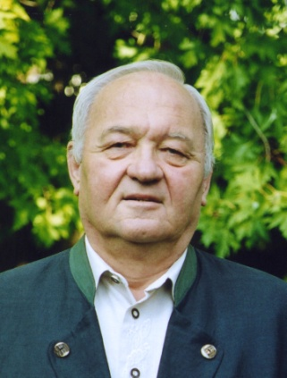
Norbert Jäger joins Huckleberry in his Quixotic Quest.
A long time ago Chicago Cub legend Ernie Banks played two in Mannheim, Germany for the US army team called the American Mannheim Tornadoes. There was a large crowd at the game and in the crowd was 11 year old Norbert Jäger.
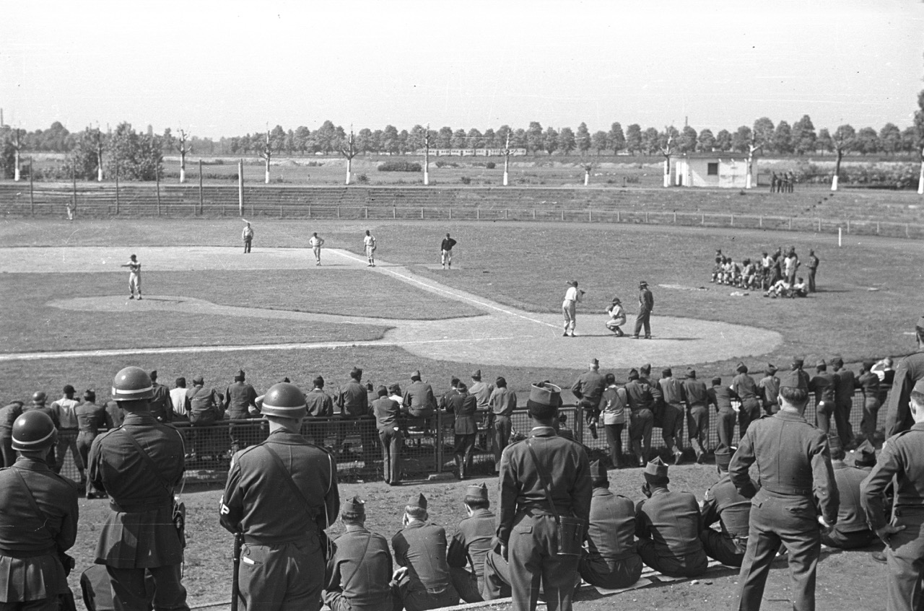
2015: Norbert Jäger
1952? US-Army Baseball in Mannheim
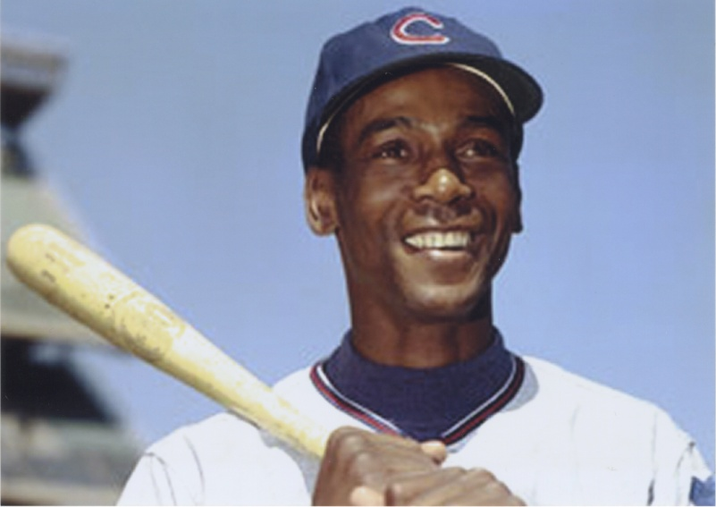
Ernie Banks rifled out some line drives including a couple laser shots that landed well beyond the boundaries of the baseball park. Ernie had great skills with a fluid motion having honed his skills in the Negro National League with the Kansas City Monarchs before being purchased by the Chicago Cubs.
Ernie played that day in Mannheim with his usual passion and love of the game. Ernie’s love for the game was contagious.
Young Norbert and his buddies were a bit confused with all the rules of baseball as it was new to Germany just brought over by the American soldiers who were occupying Germany at the time.
Ernie Bank’s easy grace, exuberance and smile helped young Norbert understand and he caught baseball fever that day! Norbert became a life- long lover of the game that he passed on to his sons and their children.
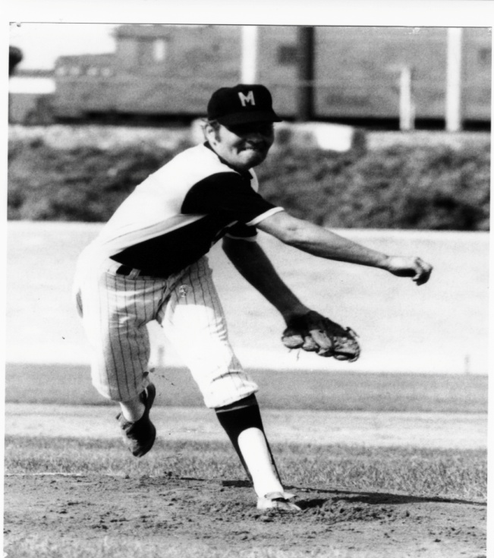
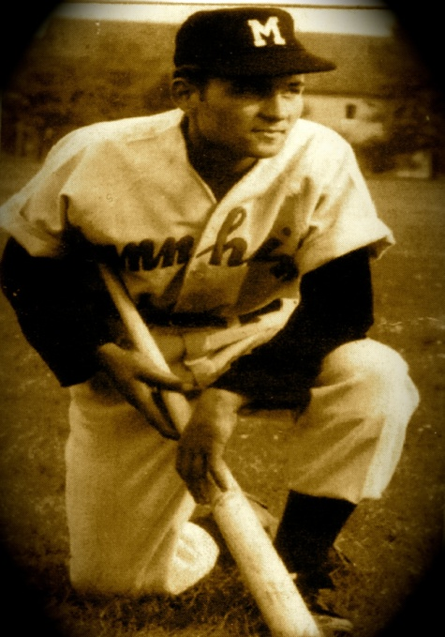
Norbert developed into quite a player as he played with and against the Americans and Germans around the military bases.
1957: Norbert Jäger 1971: Norbert Jäger
Norbert also taught his sons and anyone who wanted to learn the game of baseball.
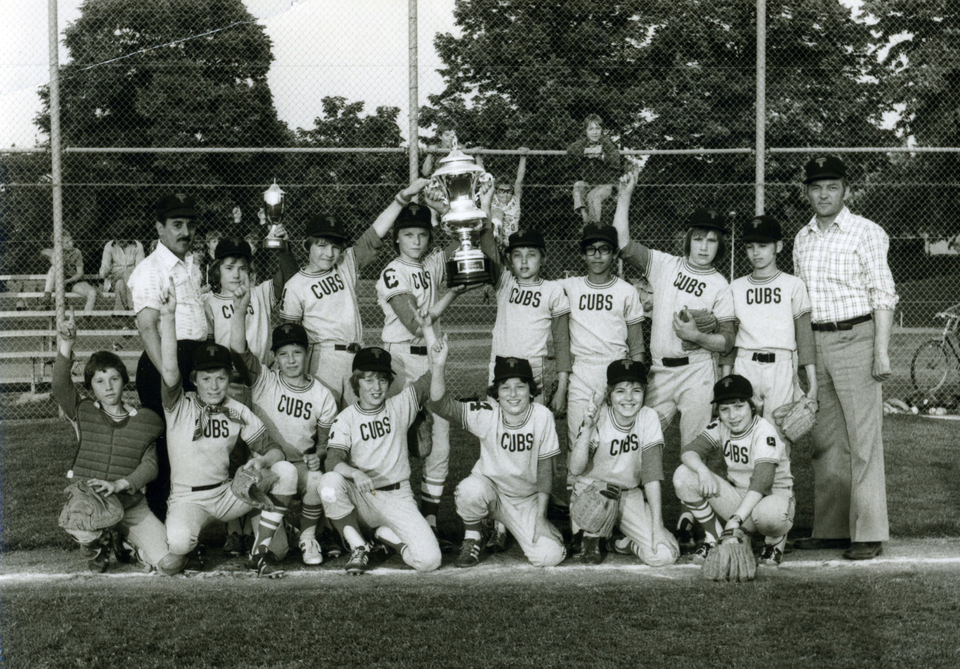
1977: Norbert Jäger coaching with his sons at the Amstedam Tournament

Norbert Jäger was instrumental in creating the German Baseball Bundesliga in 1984 and his hometown team the Mannheim Tornados, which he founded in 1975 have won 11 german championships so far — the most for any one team In German Baseball.
The Tornados had an incredible dynasty in the 80’s as Norbert’s sons and their good buddy Klaus Knüttel formed the nucleus of a team that won every Meisterschaft from 1984-1989.
The run of titles ended in 1990 when Huckleberry wandered into Cologne from Chicago via Sweden and the 1990 Bundesliga Meisterschaft was an all Köln “war” as the Cologne Dodgers and Cologne Cardinals had a series for the ages! 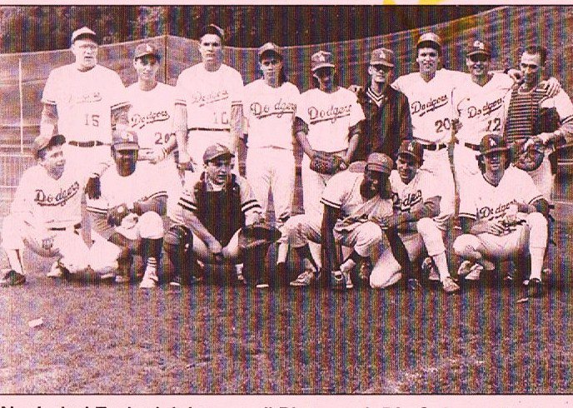

Now Norbert has joined Huckleberry in his Homeric, Quixotic Quest to try and end the curses of Da Bambino and Murphy Da Goat for the Chicago Cubs. http://www.curseofthebillygoat.tommyhuckleberrynolan.com
Huckleberry had an epiphany in the fall of 69 and vowed to the moon and stars that he would end “the curse” or whatever was making those bad bounces, broken bat hits and later a guy named Bartman from preventing the Cubs from even reaching the promised land of a World Series.
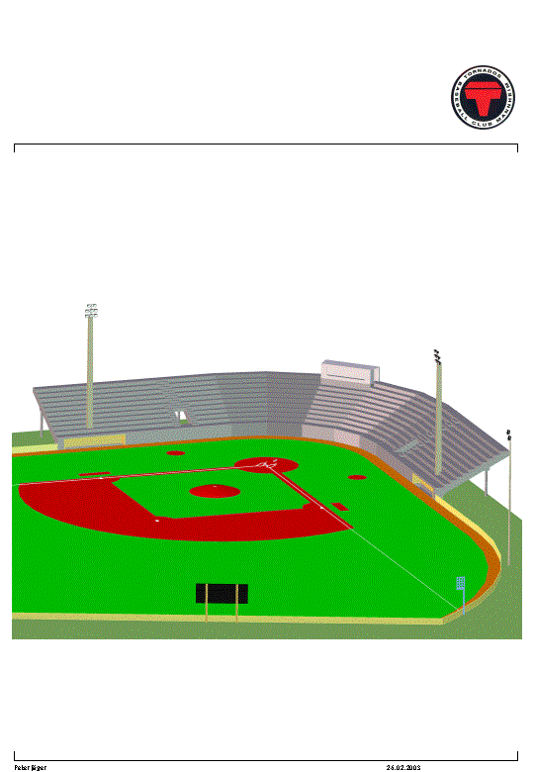
Now, Norbert and Huckleberry believe (like Ray Kinsella) that if the baseball parks are upgraded in Mannheim, Berlin and Gefle Sweden, the good spirit of people exercising and becoming one in the game will help control the uncontrollable things that sometimes control a baseball game and have made the Cubs lose..
Norbert and Huckleberry want to upgrade the baseball parks like the Cubs are doing now in Chicago complete with year round batting cages and pitching mounds under the stands like the “new Wrigley.”

This way people can meet all year round to exercise and learn more about the game. This will bring the great game of baseball to new heights of popularity in Germany, Sweden and the USA.
Norbert and Huckleberry would also would like to work with the schools to set up student/teacher/athletic exchanges to not only promote baseball but soccer and hockey as well because as JFK once said, “A rising tide lifts all boats.” Our world needs to promote peaceful pastimes that bring people together exercising and Norbert and Huckleberry believe in baseball and all the good that it creates: People coming together in the park with the smell of the green grass filling their lungs as they exercise both their minds and bodies with the peaceful pastime.
Contact:
Peter Englehardt (President of Manheim Tornados)
Nobert/Stephan Jager Tornado Baseball Hall of Famers.
0621 4310302
info@tornados.de
more info on “the curse” http://www.curseofthebillygoat.tommyhuckleberrynolan.com
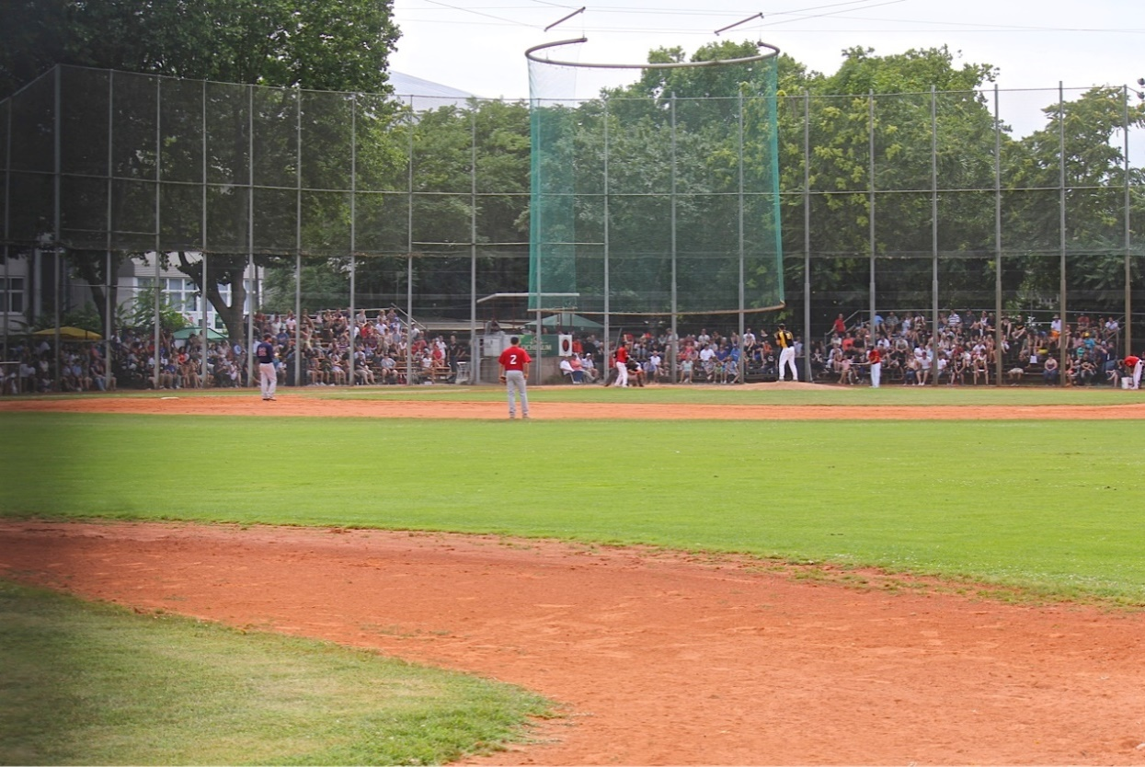
Baseball Germany 2015 –

